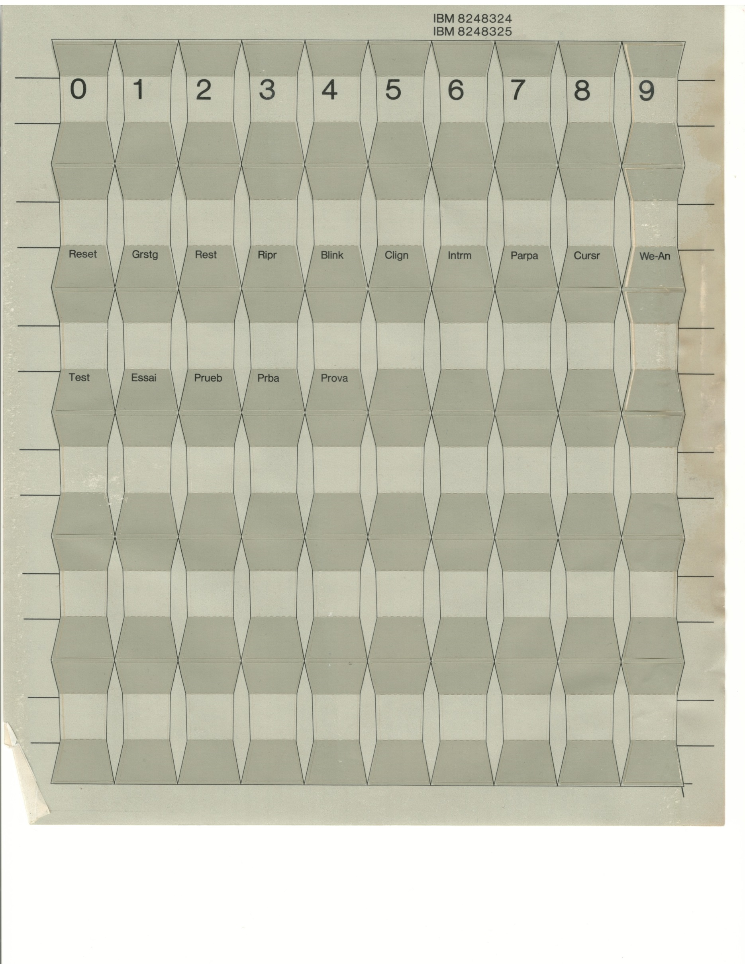
Insert Home Page
Up

Delete End Page
Down

Insert Home Page
Up

Delete End Page
Down

